TECHNICAL PORTFOLIO  Sotirios Kylintireas-Xydous  Computer Science · Systems · Machine Learning · Digital Product Work  Computer Science student at the Athens University of Economics and Business with a Finance minor at Deree – The American College of Greece. My work combines distributed systems, machine learning, data analysis, and real-world digital optimization, with a focus on projects that are both technically grounded and clearly useful.  Focus areas  - Machine Learning  - Data Engineering  - Backend Systems  - C++ Simulation  - UX & Website Optimization | Contact  skylintireas@gmail.com  github.com/KingKyli
SELECTED PROJECTS
Distributed Food Ordering System · GridWorld C++ Simulation · IMDB Sentiment Analysis · Instagram Reach EDA · Aegean Blue Houses

SELECTED PROJECTS
Distributed Food Ordering System
Android · Java · Distributed Systems
A full-stack ordering platform that combines a native Android client with a Java TCP backend and SQLite persistence. The project was designed to showcase real distributed-systems thinking rather than just a mobile UI, supporting both customer and partner / manager workflows.
Stack: Java 11, Android SDK, TCP sockets, JSON protocol, Room / SQLite, Material Design 3, Gradle (Kotlin DSL), JUnit 5
GitHub repository
Highlights
• Built around raw TCP sockets with a custom JSON protocol, explicit handshake flow, and reconnect handling instead of relying on REST or HTTP abstractions.
• Structured as a layered system (UI → Service → Repository → Protocol) so networking, business logic, and presentation remain clearly separated.
• Implemented thread-safe basket and socket handling, plus server-side validation for prices, stock, store creation, and one-time access-code login.
• Includes both customer browsing / ordering flows and a partner portal for inventory and store management, making the project end-to-end rather than feature-isolated.
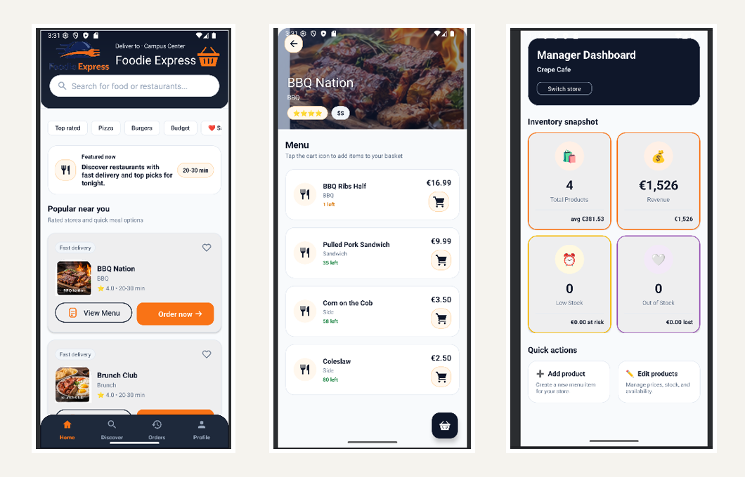
Selected Android screens: home discovery, menu / basket flow, and manager dashboard.

SELECTED PROJECTS
GridWorld — C++ Simulation Demo
C++ · Simulation · SGG
An interactive grid-based simulation / game demo built in C++ with SGG, focused on runtime control, map-driven gameplay, and visible state transitions. It includes setup, live match execution, sandbox editing, score tracking, and winner states, making it a systems-oriented demo rather than a simple graphics exercise.
Stack: C++, CMake, SGG, vcpkg-based dependency setup
GitHub repository
Highlights
• Supports pause / run, single-step execution, speed changes, restart, next-map switching, and configurable match duration, which makes the simulation useful for deterministic debugging as well as gameplay.
• The live HUD exposes FPS, elapsed time, remaining targets, CPU mode, score, and A* / search information, turning the demo into an inspectable systems artifact.
• Includes multiple map styles plus a sandbox edit mode where obstacles can be drawn or erased interactively for rapid experimentation.

Composite from the C++ GridWorld demo: setup, runtime views, sandbox mode, and winner states.

SELECTED PROJECTS
Sentiment Analysis — IMDB Dataset
ML · NLP · Deployment
An end-to-end NLP pipeline for binary sentiment classification on 50,000 IMDB reviews. The work was upgraded from a course notebook into a portfolio-ready project with reproducible training scripts, benchmarking, a live Streamlit demo, and multilingual inference support for Greek input.
Stack: Python, scikit-learn, TF-IDF, Logistic Regression, Streamlit, HuggingFace / DistilBERT, NumPy
Live demo · GitHub profile
Highlights
• Implemented Bernoulli Naive Bayes and Logistic Regression from scratch in Python / NumPy to demonstrate understanding of the underlying methods, not only library usage.
• Benchmarked multiple TF-IDF models and used Logistic Regression for deployment because it balanced performance, interpretability, and lightweight inference.
• Added a DistilBERT reference benchmark as a stronger comparison point while documenting why it was not selected for deployment.
• Built a live demo and kept evaluation artifacts such as metrics, confusion matrix, error analysis, and model comparison outputs.

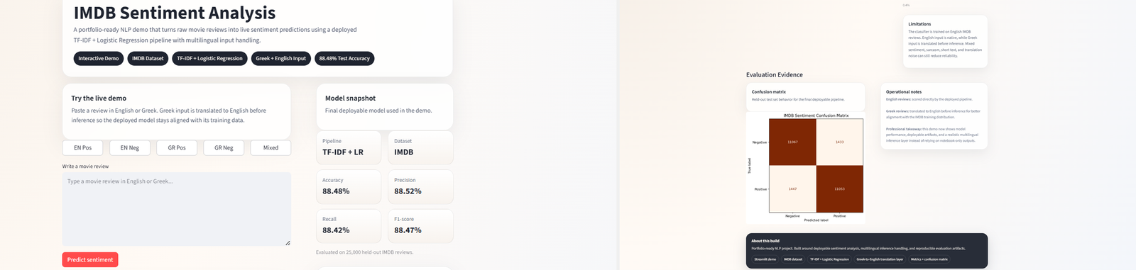

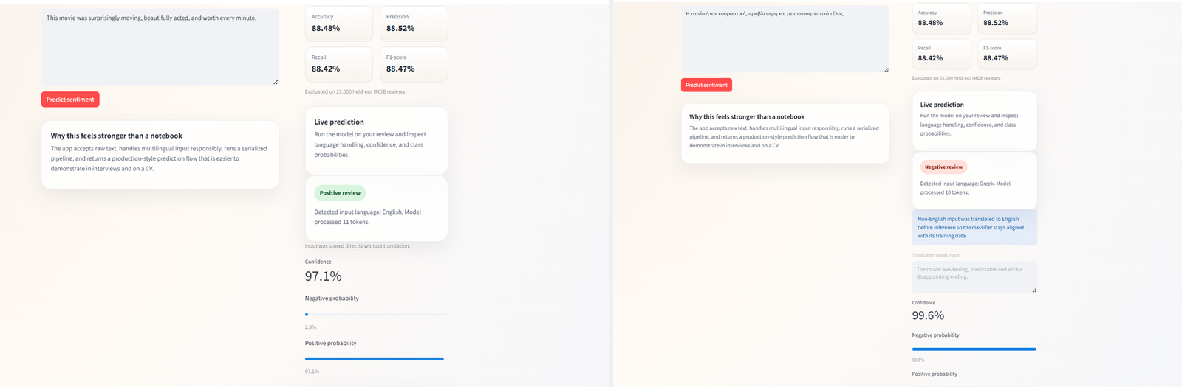

SELECTED PROJECTS
Instagram Reach Dataset — EDA & Logistic Regression
R · EDA · Classification
Exploratory data analysis and interpretable binary classification on an Instagram engagement dataset. The project moves from data inspection and feature engineering to logistic regression modeling, with emphasis on readable statistical reasoning and honest evaluation.
Stack: R, R Markdown, exploratory data analysis, logistic regression
GitHub repository
Highlights
• Structured as a full mini-report covering objective, inspection, descriptive statistics, distribution analysis, correlation analysis, modeling, evaluation, conclusions, and limitations.
• Identified that hours since posting was the strongest statistically significant predictor in the model, while follower count had a weaker effect.
• Evaluated the classifier on a held-out test split, reaching 83.3% accuracy and AUC 0.727 while explicitly documenting class imbalance and moderate recall limitations.
• Useful as a recruiter-friendly analytics project because the modeling choices remain interpretable and clearly tied to business-style questions.

LIVE WEBSITE CASE STUDY
Aegean Blue Houses — Website Optimization
Live site · WordPress · Elementor · Custom CSS / HTML · WPML · Direct Inquiry UX
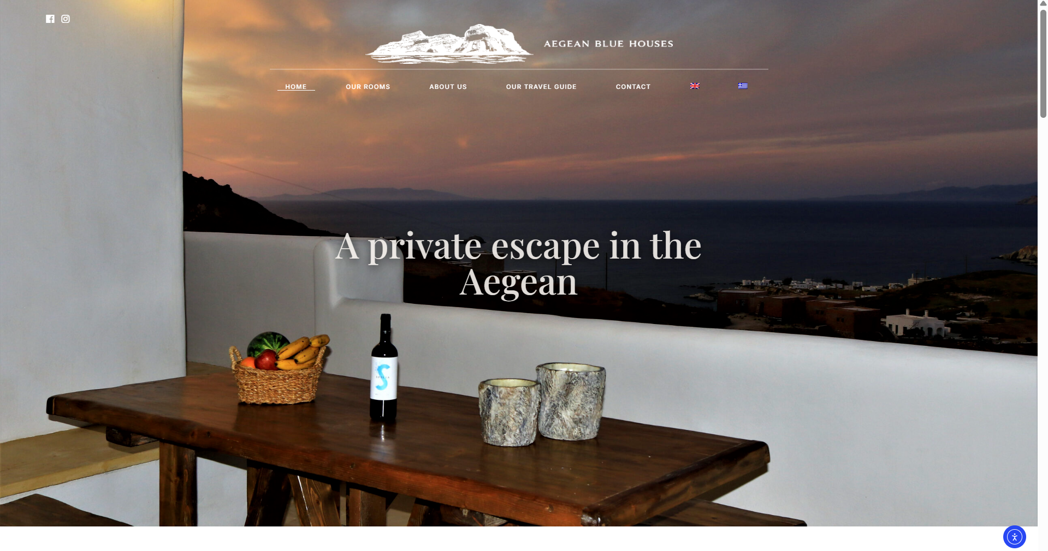
Recent homepage refinement showing the updated premium editorial direction.
Ongoing redesign and optimization of a live bilingual hospitality website for a family-run accommodation business in Milos. The work sits inside an existing production stack — WordPress, Elementor, Contact Form 7, MotoPress components, and WPML — so the challenge is not a clean rebuild, but upgrading the experience while respecting real operational constraints.
WHAT I IMPROVED  • Premium homepage section hierarchy and calmer spacing  • More polished room-discovery presentation and visual consistency  • Better direct inquiry flow and contact-page clarity  • Bilingual structure that works in both Greek and English | BUSINESS / TECH CONTEXT  • Live production site for a real hospitality business  • Worked within Elementor and existing theme / plugin constraints  • Used custom HTML and CSS wherever the visual builder was insufficient  • Focused on aesthetics, responsiveness, and conversion rather than feature bloat

The stronger version of this project is not simply “I edited a website,” but that I improved a live, customer-facing digital experience with a clear hospitality brand direction. That includes premium visual hierarchy, better inquiry usability, room-page consistency, and practical collaboration with the limitations of a real WordPress setup.
Live site: aegeanbluehouses.com
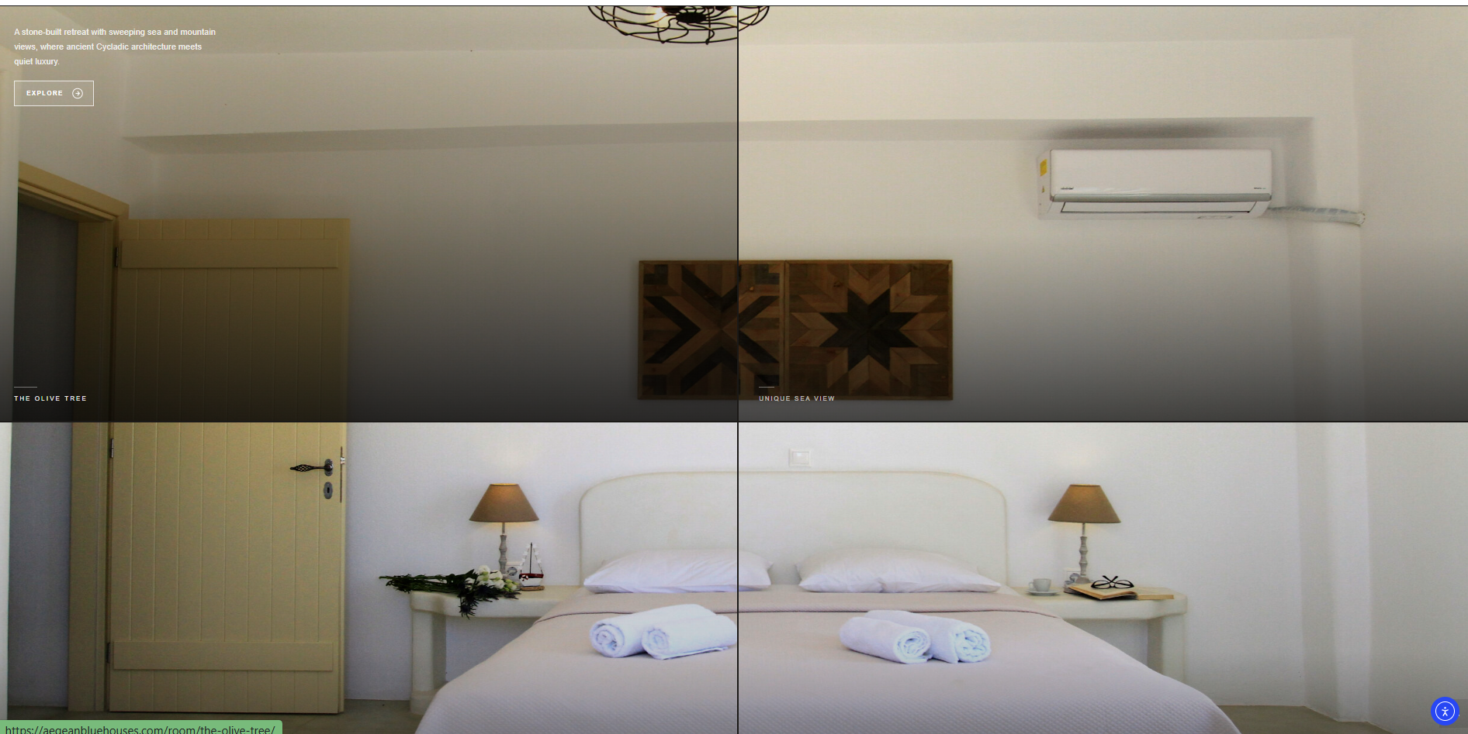

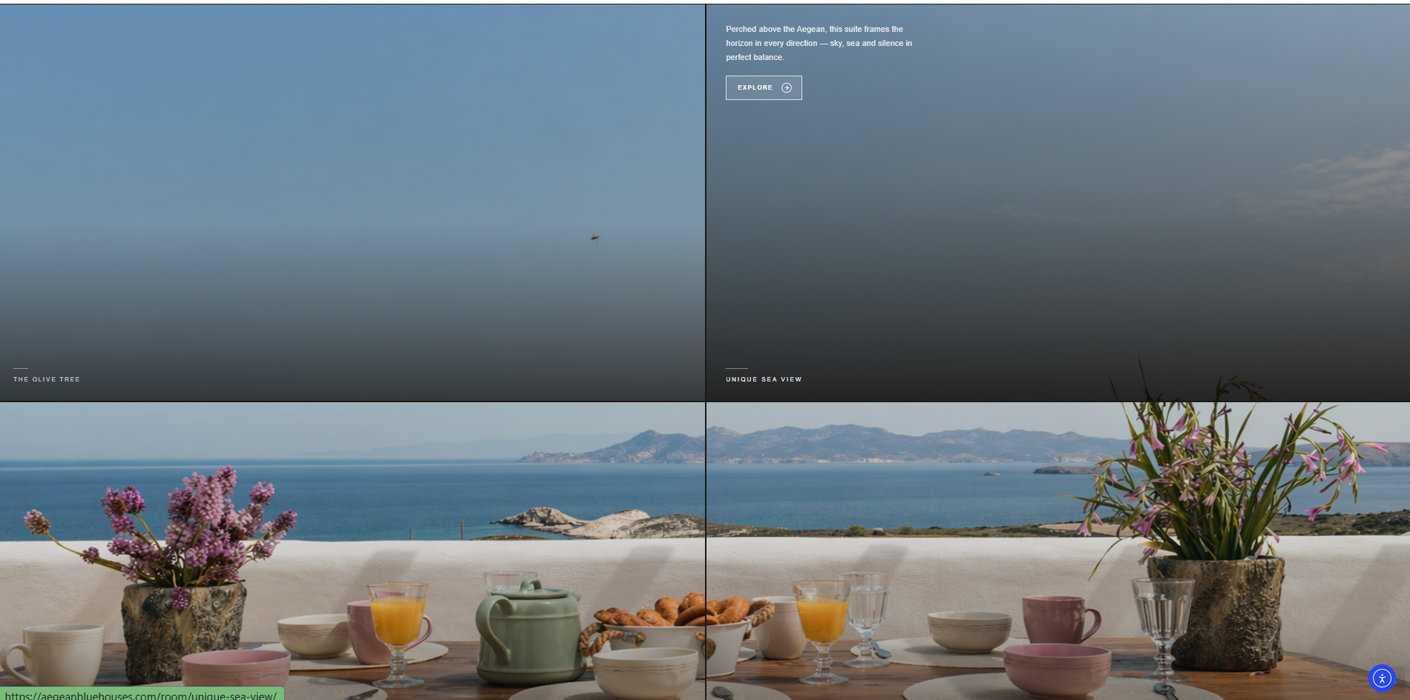
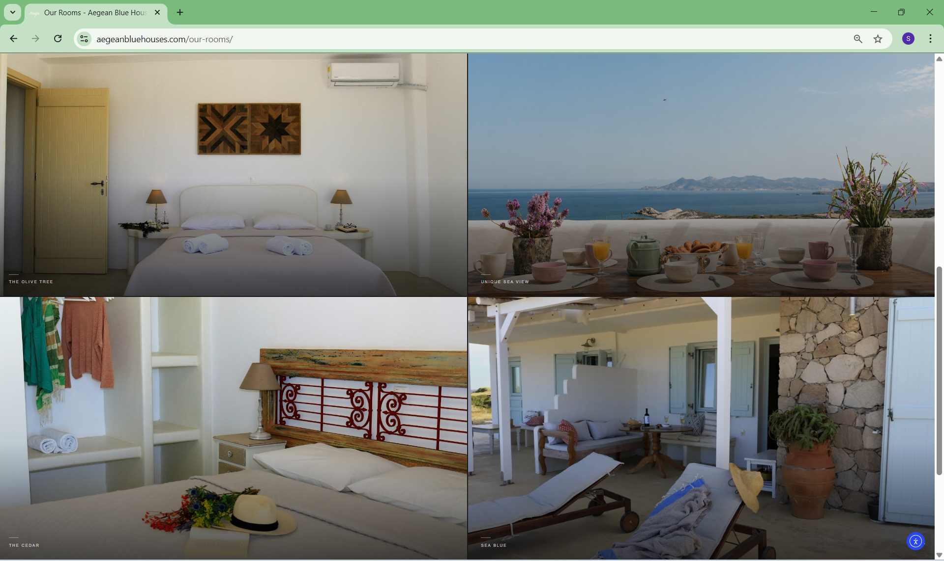

Room discovery & Presentation Section

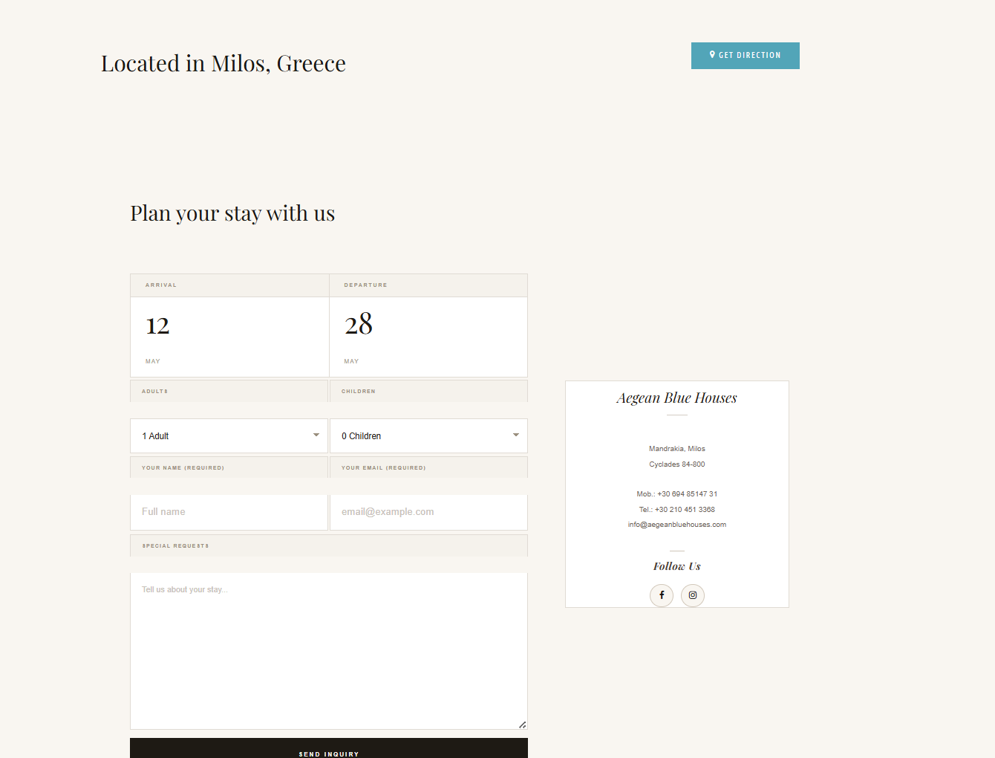
Direct inquiry / contact flow

This section is intentionally more visual because the value of the project is partly technical and partly experiential: the outcome has to look premium, feel coherent, and convert users in a live hospitality setting.

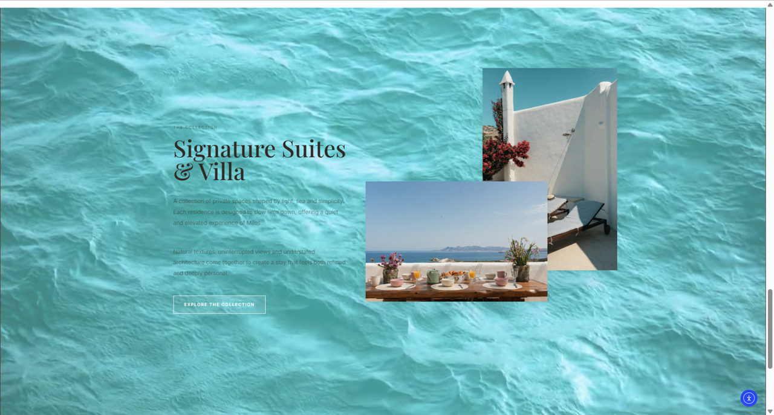
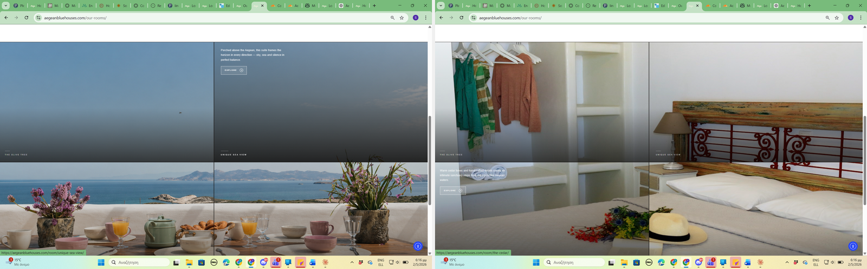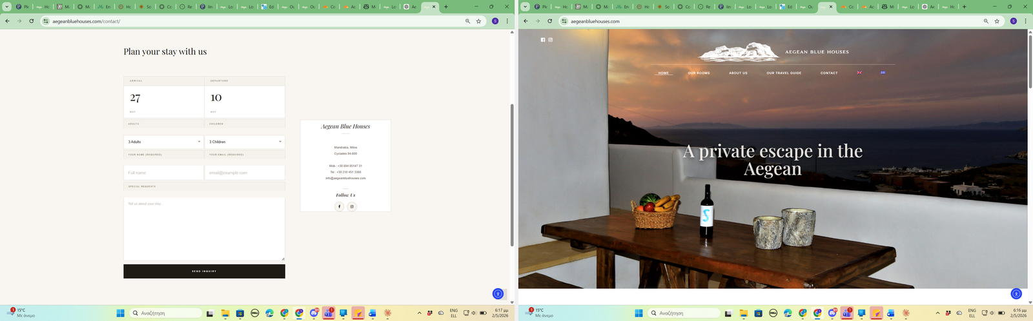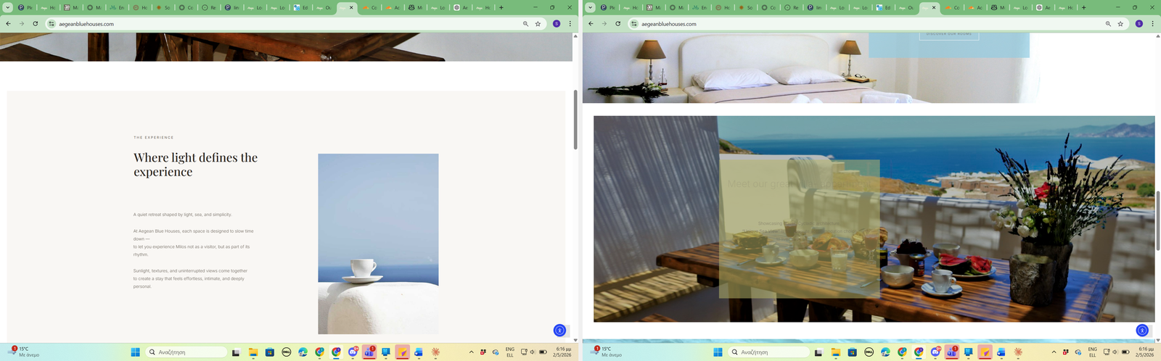
Links
GitHub — Distributed Food Ordering System
GitHub — GridWorld C++ Simulation
GitHub — Data Analysis Project
Live site — Aegean Blue Houses

